MongoDB Assignment 2

**Atlanta Population:**

1.Use db.zipcodes.find() to filter results only the results where city is ATLANTA and state is GA.

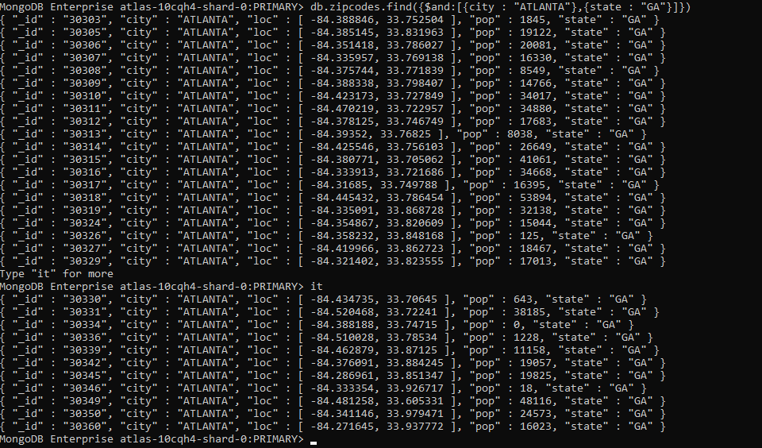

2.Use db.zipcodes.aggregate with $match to do the same as above

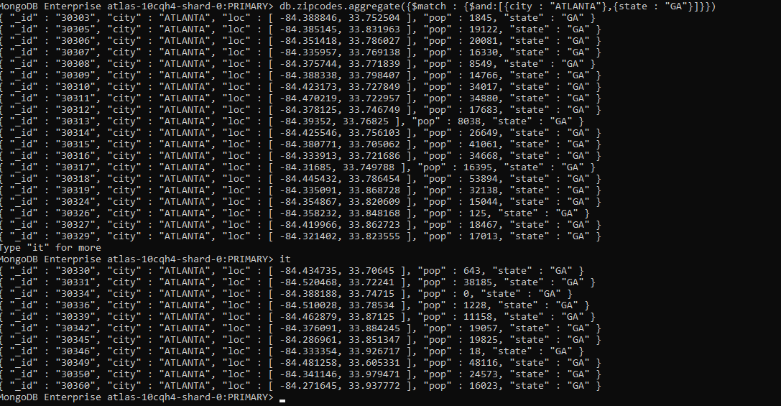

3.Use $group to count the number of zip codes in Atlanta.



4. Use $group to find the total population in Atlanta.



**Population By State:**

5. Use aggregate to calculate total population for each state.

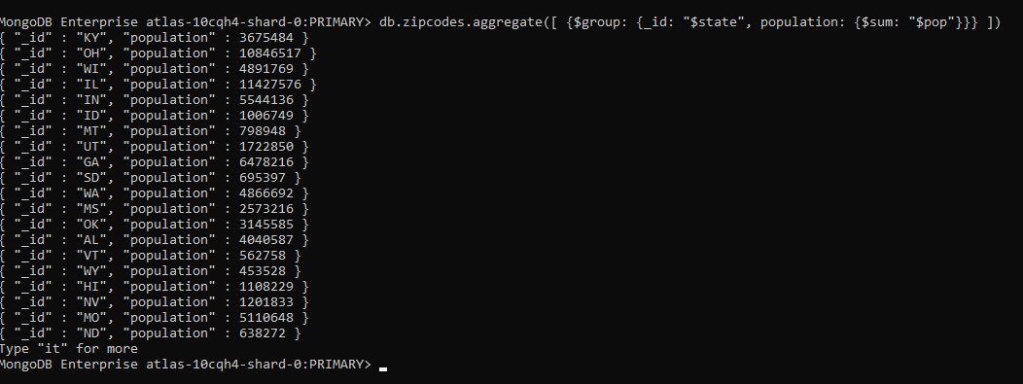

6.Sort the results by population,highest first.

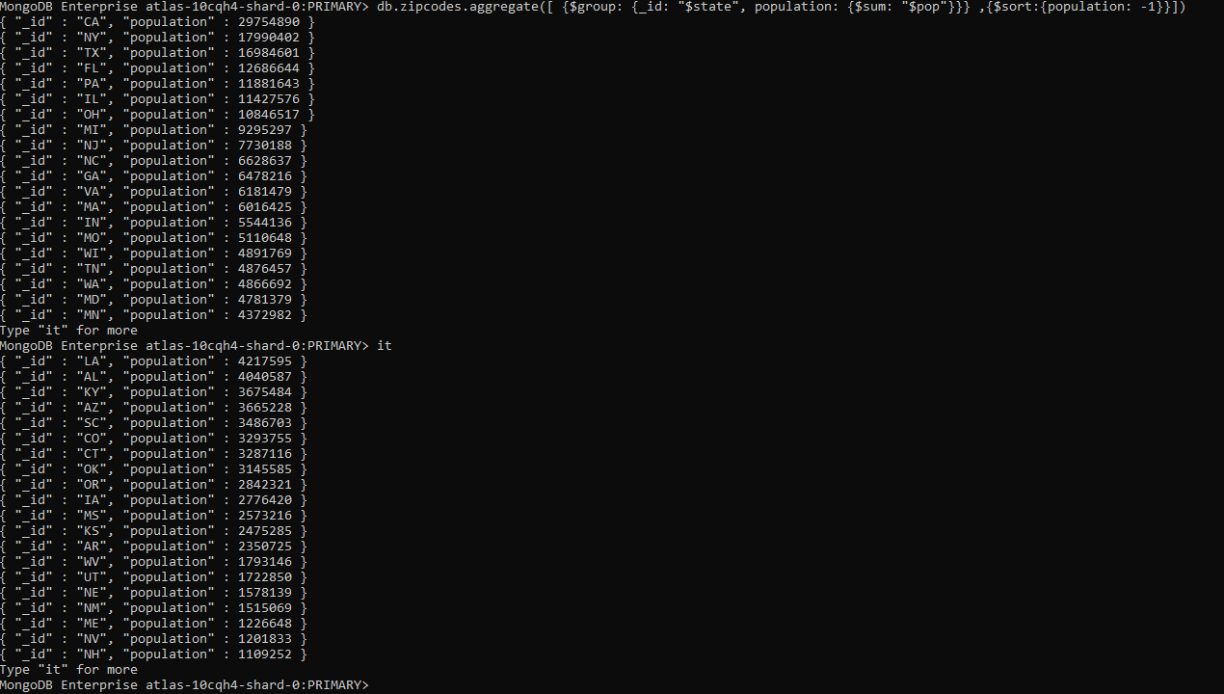

7.Limit the results to just the first 3 results.



**Population By City:**

8.Use aggregate to calculate the total population for each city.

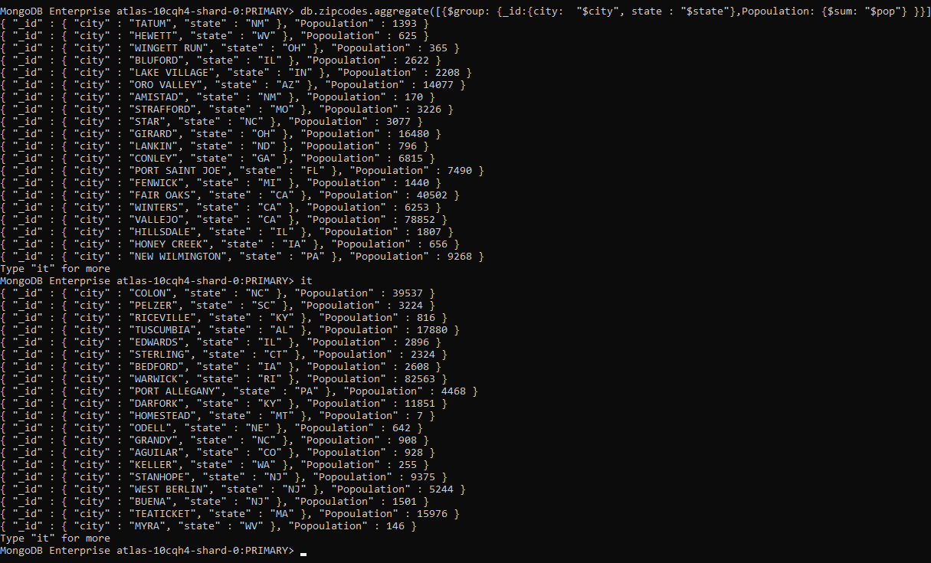

9.Sort the results by population, highest first.

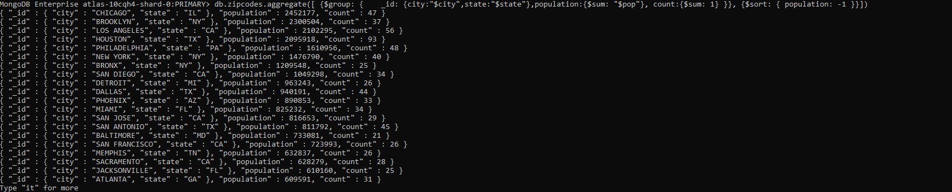

10.Limit the results to just the first 3 results.



11.What are the top 3 cities in population in Texas.



**Bonus:**

1.Write a query to get the average city population for each state.

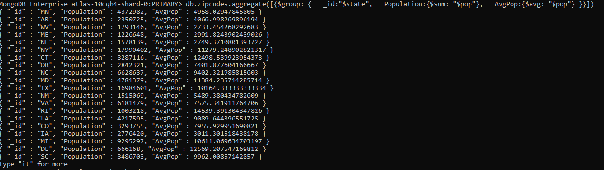

2.Write are the top 3 states in terms of average city population.

